# INTRODUCTION

* 1. Overview

**Administrator should be able to create all base dataincluding Semester, Candidate, Course and Lecturer, Lecturer should have the ability to create Internal Results, Dean, who is one of the Lecturer, should be the only one with ability to update Internal Results, Re-evaluation Can be initialized by Candidate for all Internal Results. Now only dean can update the marks after re-evaluation.**

* 1. Purpose

It saves time. You take most time efficient route, achieving desired CRM results and scoring goals faster. It saves money. You now exactly what type of solution to seek and all the costs associated with it, only spending as much as you need to. It helps you make the most out of your CRM. Get everyone on the same page from oday one, marching towards maximum effectiveness.

1. **ProblemDefinition& DesignThinking**
   1. EmpathyMap

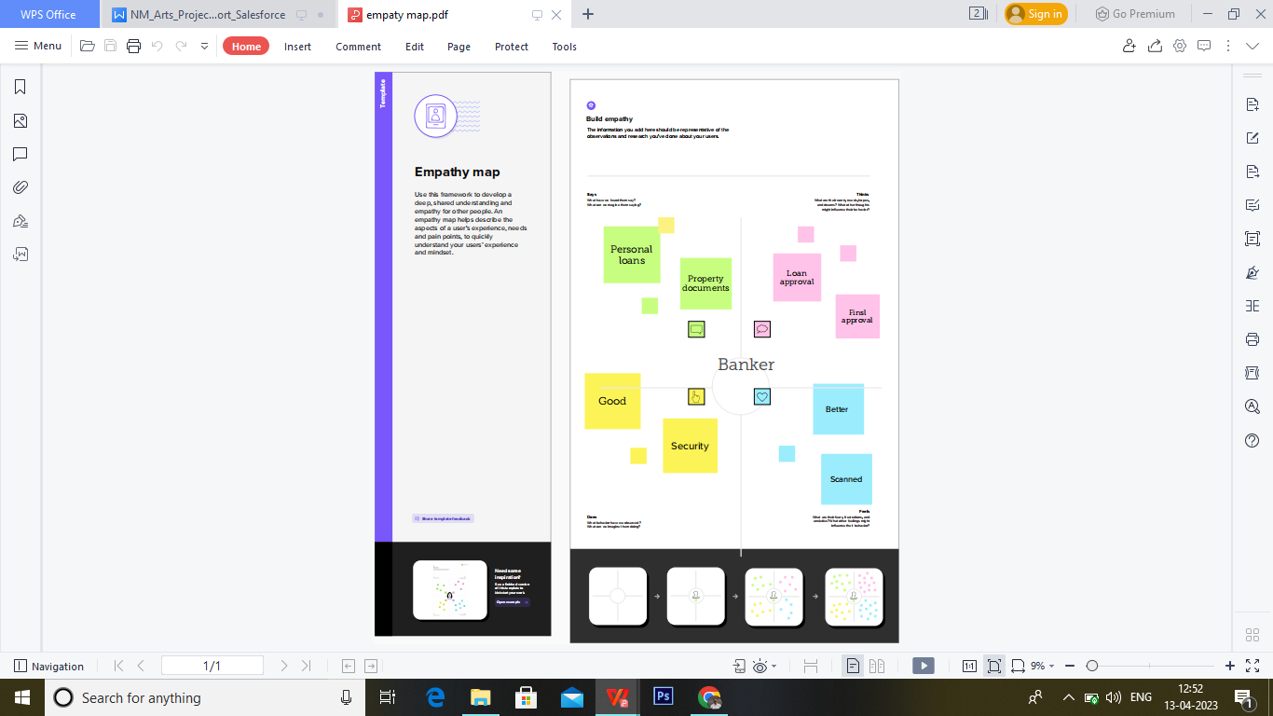

* 1. Ideation&BrainstormingMap

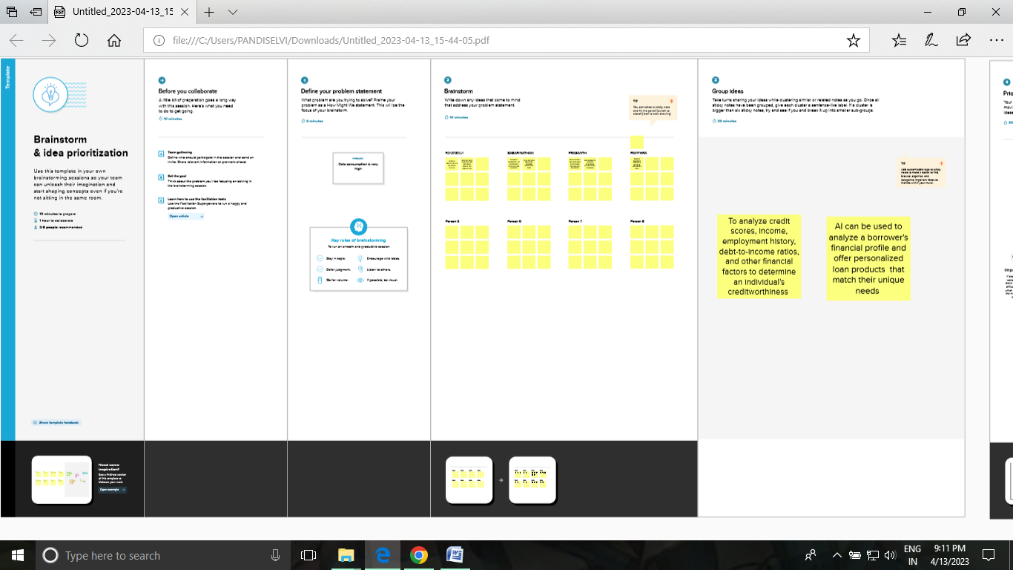

# RESULT

* 1. DataModel:

|  |  |
| --- | --- |
| **Objectname** | **FieldsintheObject** |
| Semester | |  |  | | --- | --- | | Fieldlabel | Data type | | Semester | Text | |  |  | |
| Candidate | |  |  | | --- | --- | |  |  | |  |  |   Field Label Data type  Candidate Text |
| Course  Details | |  |  | | --- | --- | | Field label | Data type | | Course Details | Text | |  |
| Lecturer  Details | |  |  | | --- | --- | | Field label | Data type | | Lecturer Details | Text | |
| Internal  results | |  |  | | --- | --- | | Field label | Date type | | Internal result | Text | |

# ActActivity&Screenshot

Att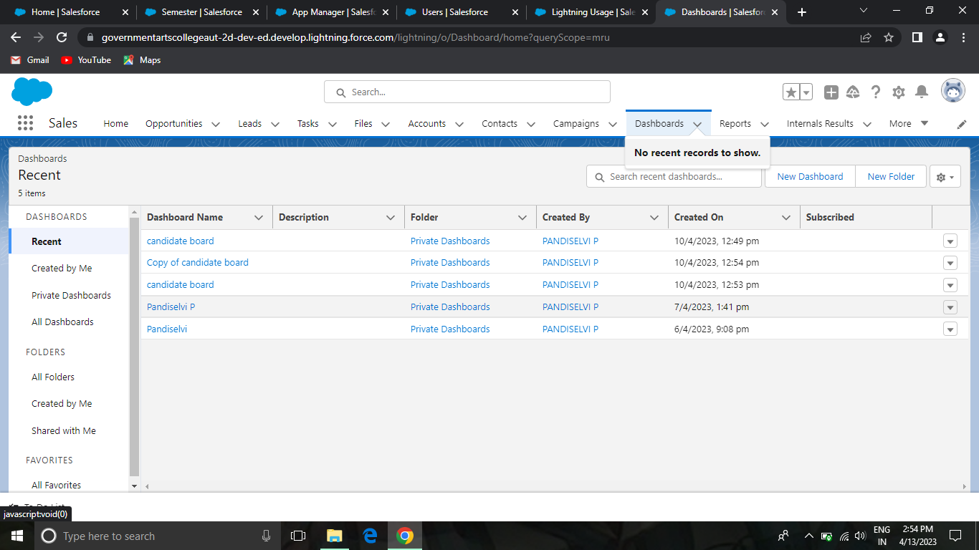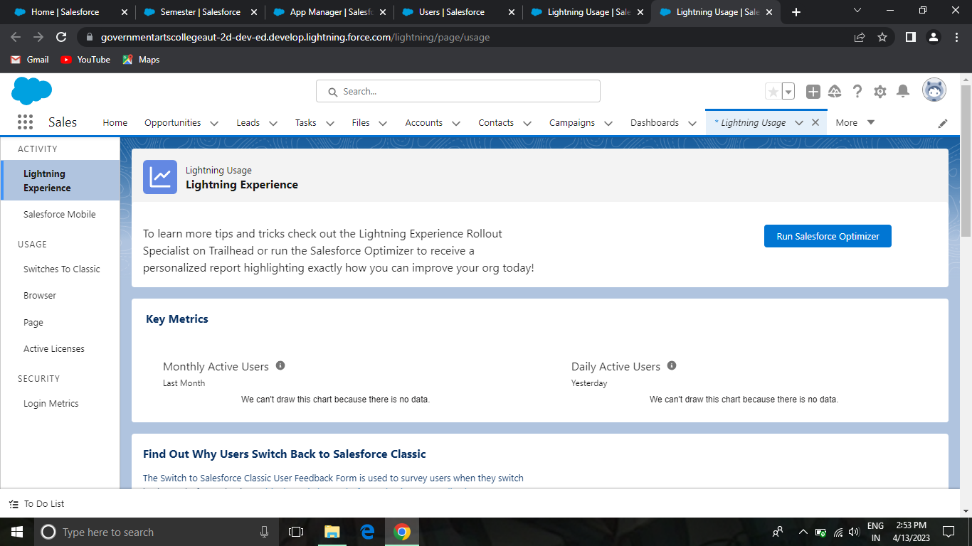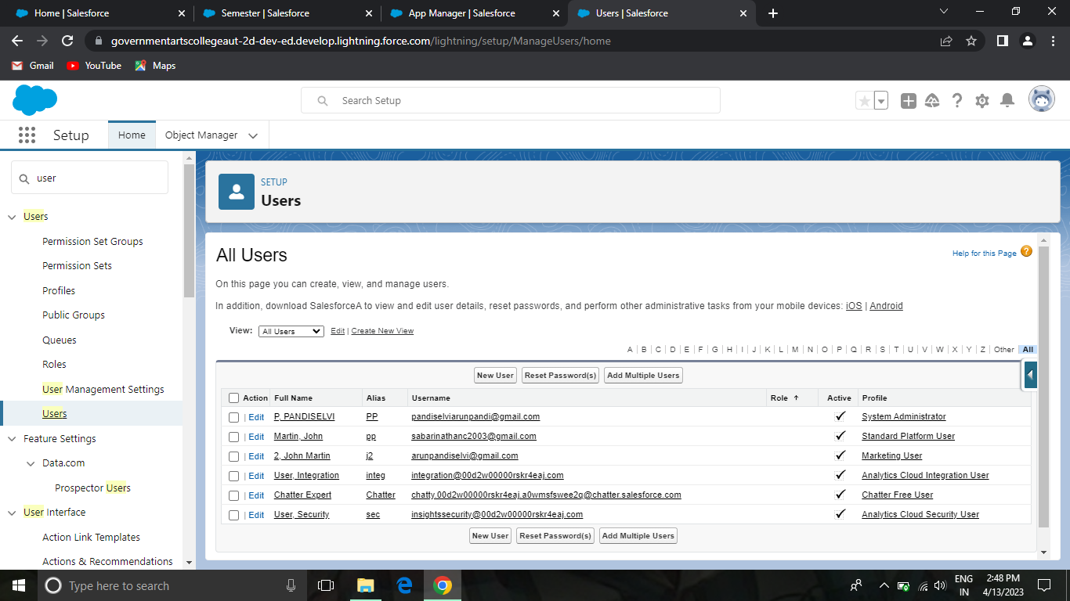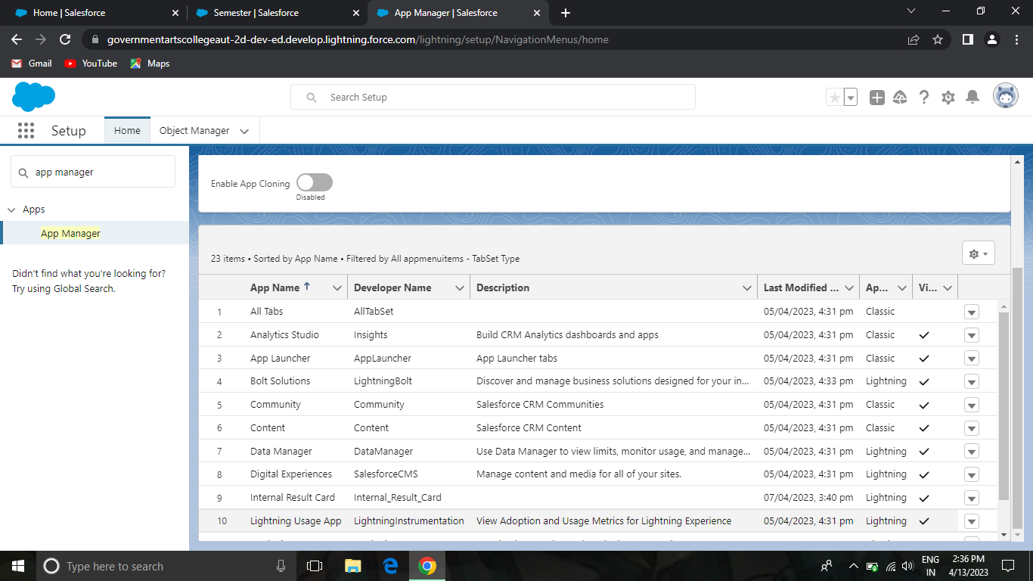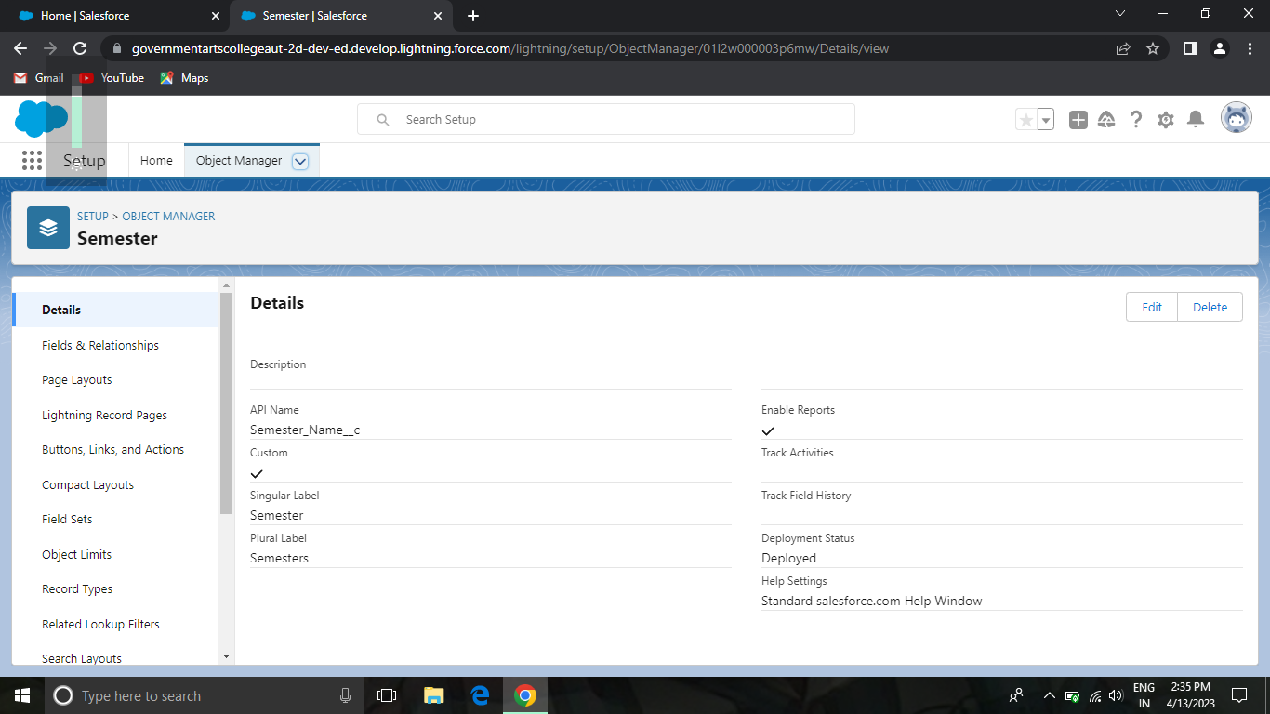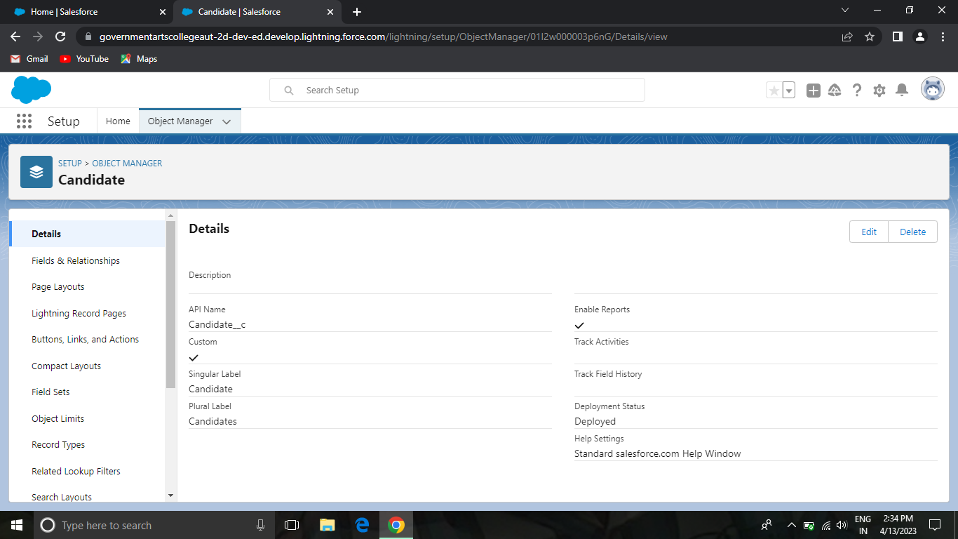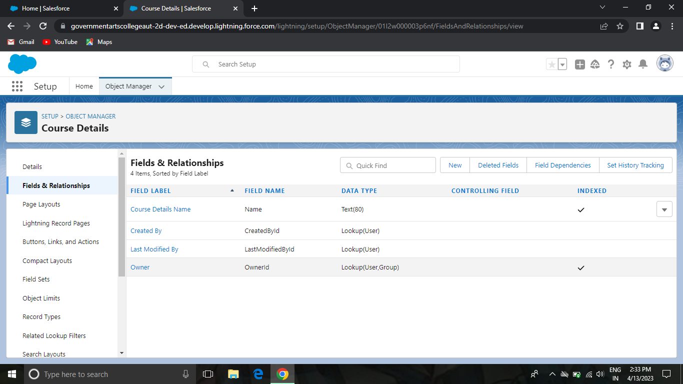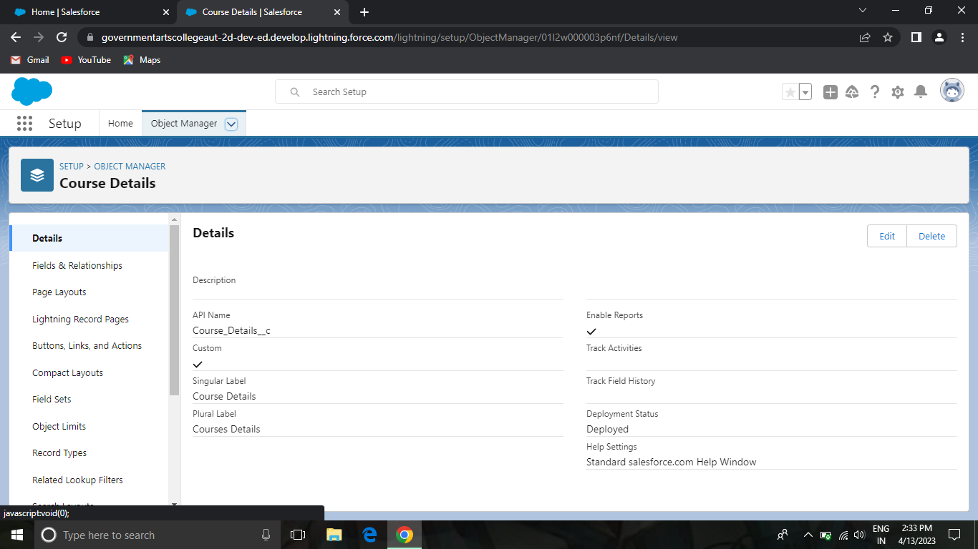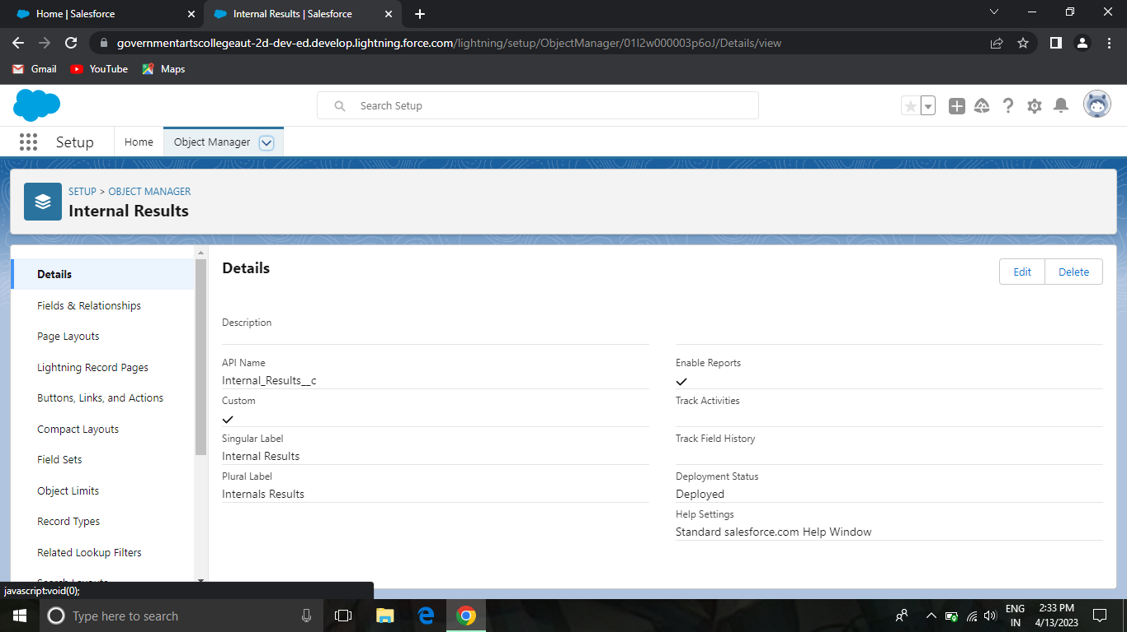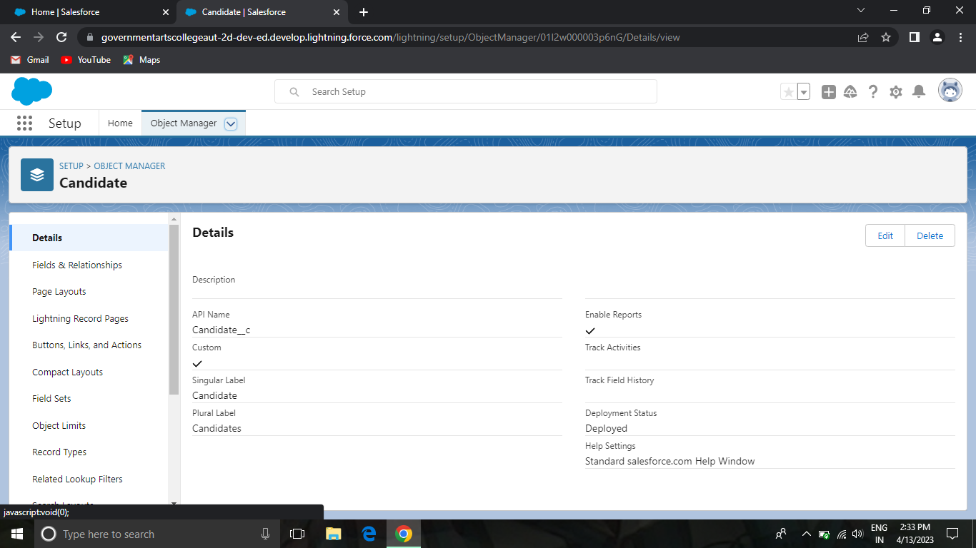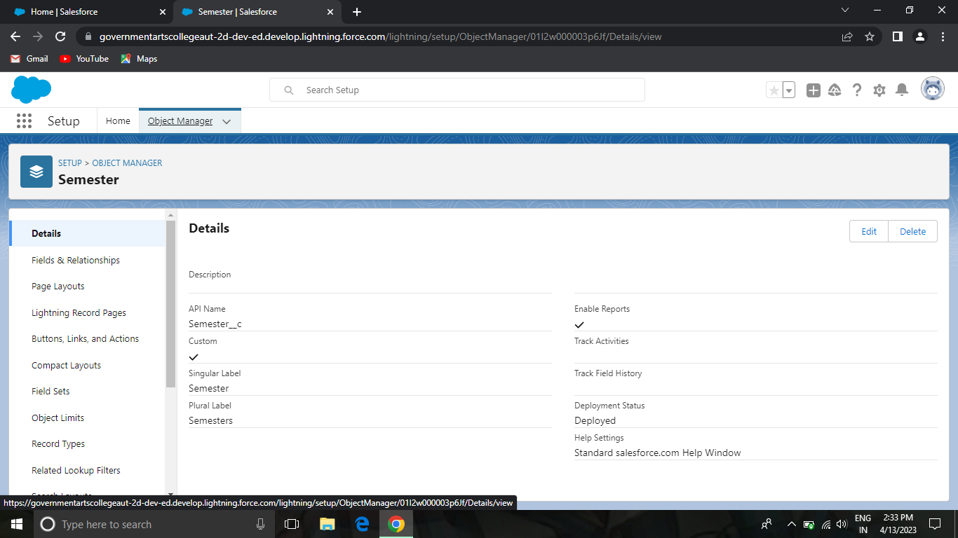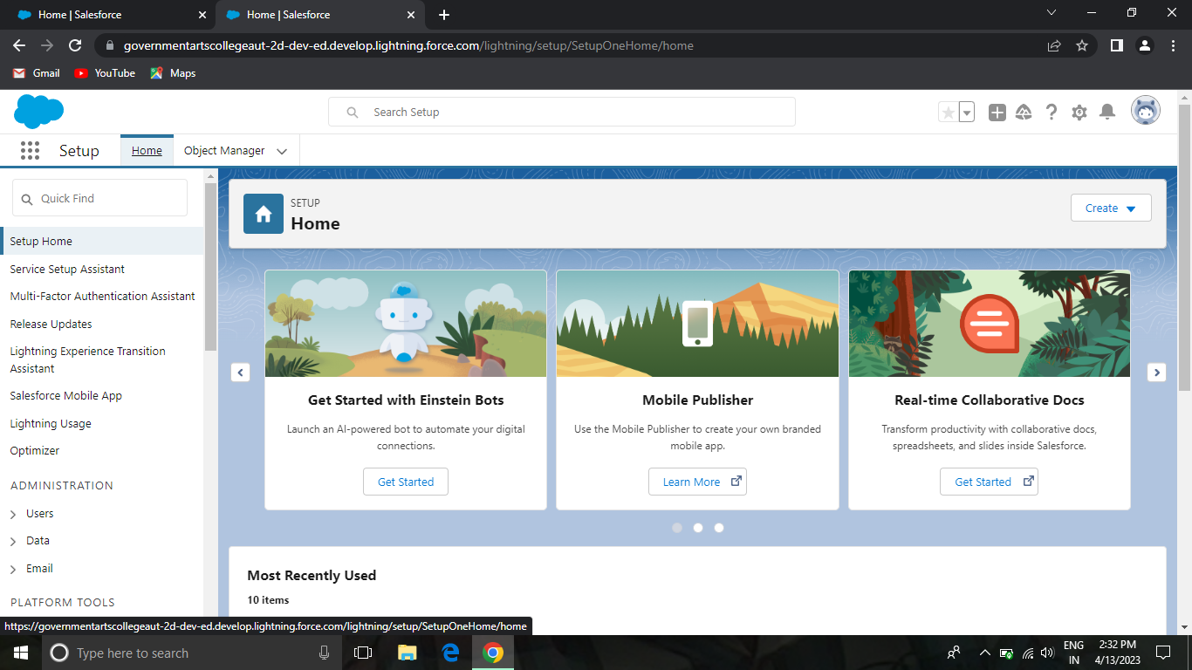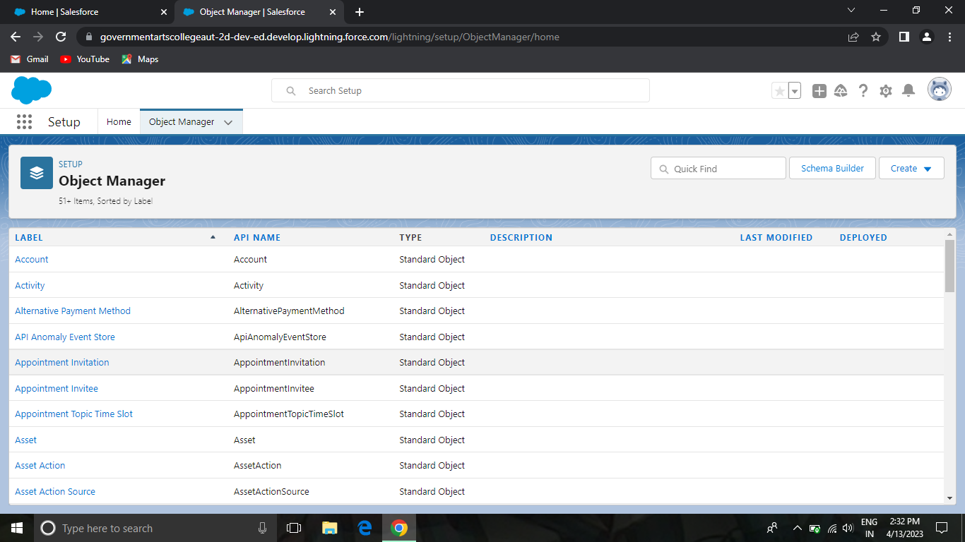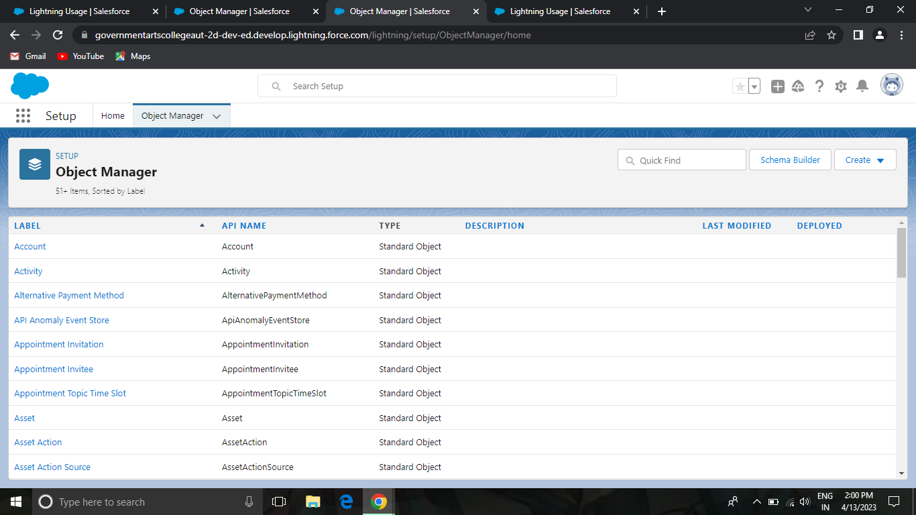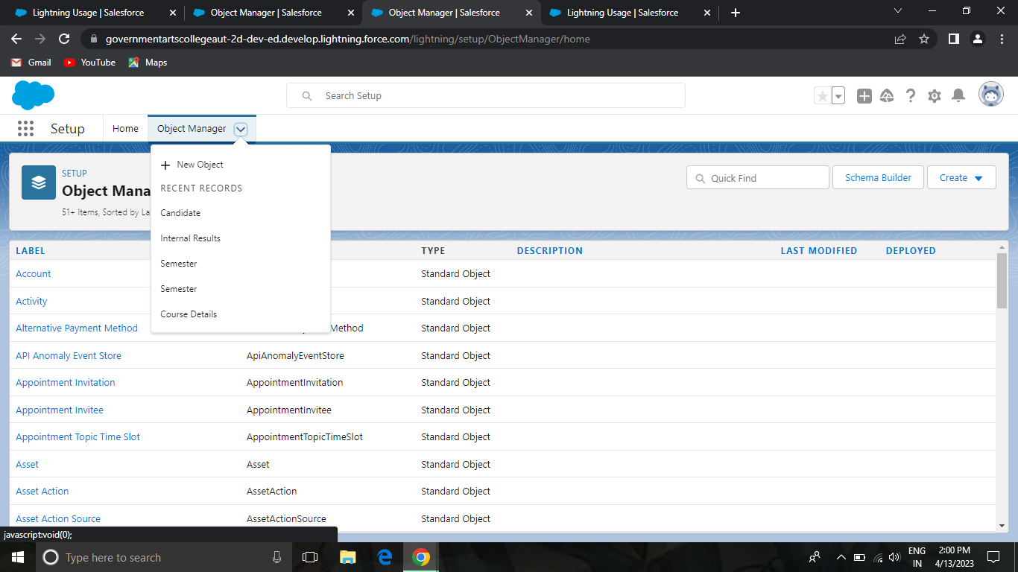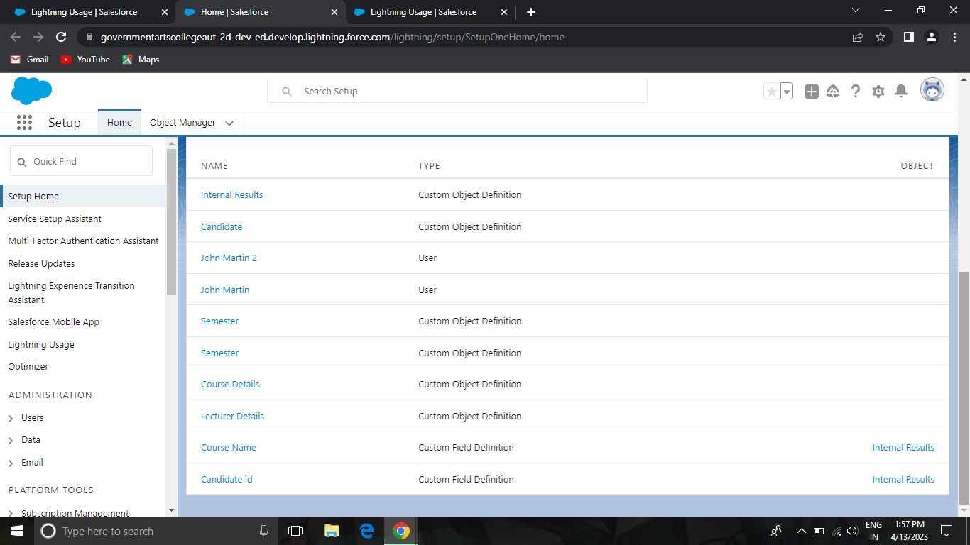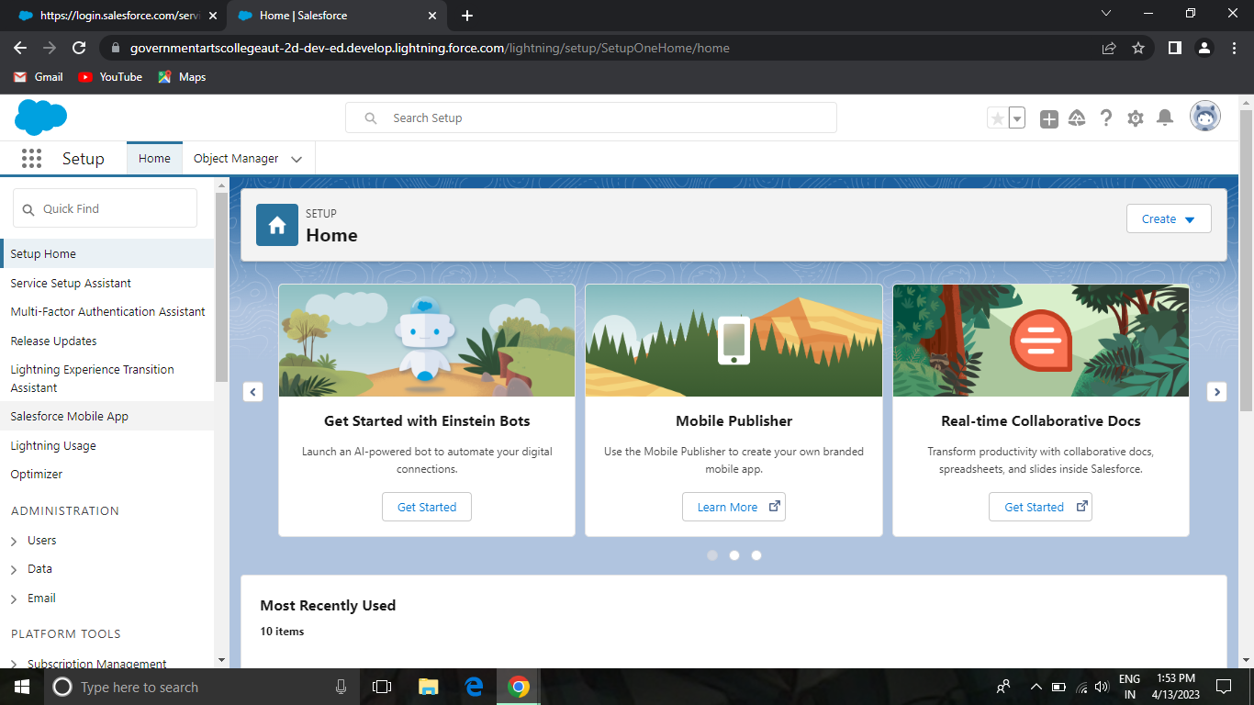

# TrailheadProfilePublicURL

**Team Lead: Pandiselvi** https://trailblazer.me/id/pandp4

**TeamMember 1- Sabarinathan C https://trailblazer.me/id/hgahlot3**

# Team Member 2– Prasanth C https://trailblazer.me/id/hgahlot3

# TeamMember 3 –

Pavithra V -https://trailblazer.me/id/hgahlot3

1. **ADVANTAGES&DISADVANTAGE**

• [Advantages of internal recruitment](https://resources.workable.com/stories-and-insights/advantages-disadvantages-of-internal-recruitment#advantages-of-internal-recruitment)

* [Reduce time to hire](https://resources.workable.com/stories-and-insights/advantages-disadvantages-of-internal-recruitment#reduce-time-to-hire)
* [Shorten onboarding times](https://resources.workable.com/stories-and-insights/advantages-disadvantages-of-internal-recruitment#shorten-onboarding-times)
* [Cost less](https://resources.workable.com/stories-and-insights/advantages-disadvantages-of-internal-recruitment#cost-less)
* [Strengthen employee engagement](https://resources.workable.com/stories-and-insights/advantages-disadvantages-of-internal-recruitment#strengthen-employee-engagement)

• [Disadvantages of internal recruitment](https://resources.workable.com/stories-and-insights/advantages-disadvantages-of-internal-recruitment#disadvantages-of-internal-recruitment)

* [Create resentment among employees and managers](https://resources.workable.com/stories-and-insights/advantages-disadvantages-of-internal-recruitment#create-resentment-among-employees-and-managers)
* [Leave a gap in your existing workforce](https://resources.workable.com/stories-and-insights/advantages-disadvantages-of-internal-recruitment#leave-a-gap-in-your-existing-workforce)
* [Limit your pool of applicants](https://resources.workable.com/stories-and-insights/advantages-disadvantages-of-internal-recruitment#limit-your-pool-of-applicants)
* [Result in inflexible culture](https://resources.workable.com/stories-and-insights/advantages-disadvantages-of-internal-recruitment#result-in-inflexible-culture)

# APPLICATIONS

Application Implementation Methodology (AIM) is a system framework of related elements. It involves certain tasks, processes, phases and dependencies: A task is a unit of work, which results in a single deliverable which may take many different forms like reports, schedules, codes, or test results.

# CONCLUSION

Towards the end of project implementation phase, the desired result of the project takes more and more shape: we integrate, test, and commission last sub-parts. The end product or service is essentially put together.

# FUTURESCOPE

The project has a very vast scope in future. The project can be implemented on intranet in future. Project can be updated in near future as and when requirement for the same arises, as it is very flexible in terms of expansion. With the proposed software of database Space Manager ready and fully functional the client is now able to manage and hence run the entire work in a much better, accurate and error free manner. The following are the future scope for the project.